***Internship Project Report on IoT by Up Skill***

**Industrial Internship Report on**

**”PLANT MONITORING SYSTEM”**

**Prepared by:**

**[Shivam Upadhyay]**

Abstract:

The Internet of Things (IoT) has revolutionized various industries by enabling the interconnection of devices and the collection of real-time data. One such application is the IoT-based Plant Monitoring System, which adds IoT technology to monitor and manage the growth and health of plants remotely. This project report presents the design, implementation, and results of a Plant Monitoring System using IoT.

Content:

Abstract

Introduction

2.1 Background

2.2 Objectives

System Architecture

3.1 IoT Sensors

3.2 Microcontroller

3.3 Cloud Server

3.4 Web/Mobile Application

Implementation

4.1 Hardware Setup

4.2 Software Development

4.3 Web/Mobile Application Development

Results

Conclusion

Future Enhancements

References

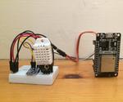

PLANT MONITORING SYSTEM

1. Introduction:

The goal of this project is to develop a Plant Monitoring System that provides real-time insights into the environmental conditions surrounding plants and their overall health. With the rising demand for sustainable agriculture and urban gardening, such a system can play a pivotal role in optimizing plant care and resource usage. The system utilizes various IoT sensors to monitor key parameters such as temperature, humidity, soil moisture, and light intensity. The collected data is transmitted to a central server via the internet, allowing users to access and analyse the information through a web or mobile application.

1. Objectives:

The main objectives of the IoT-based Plant Monitoring System are as follows:

* Monitor environmental parameters: Deploy sensors to monitor crucial environmental factors such as temperature, humidity, soil moisture, and light intensity around the plants.
* Data collection and storage: Establish a seamless data flow from the sensors to a centralized database for real-time data storage and historical analysis.
* Real-time notifications: Enable the system to send real-time alerts and notifications to users in case of unfavourable conditions for the plants, such as high temperature or low soil moisture.
* Remote plant control: Develop features that allow users to remotely control the watering and lighting of the plants through the web or mobile application.
* Intuitive user interface: Create an intuitive and user-friendly web or mobile interface for data visualization and system control.

plant monitoring using IoT.

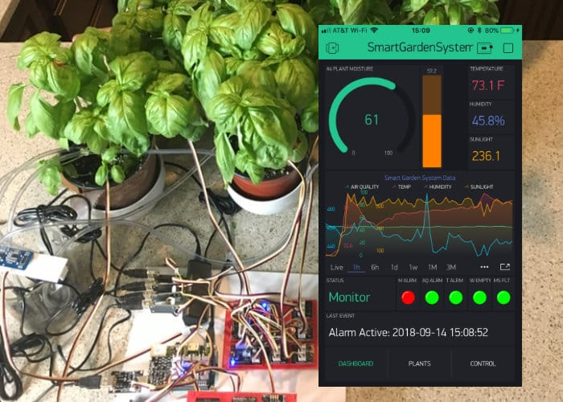

1. System Architecture:

The Plant Monitoring System consists of the following components:

3.1. IoT Sensors

The core of the system relies on various IoT sensors, including:

* Temperature Sensor: This sensor measures the ambient temperature around the plants, providing crucial information about the plant's response to its environment.
* Humidity Sensor: Monitoring relative humidity helps assess the moisture content in the air, which is vital for maintaining optimal growth conditions.
* Soil Moisture Sensor: By measuring soil moisture levels, the system can determine if the plants need watering, preventing under or overwatering.
* Light Intensity Sensor: This sensor gauges the amount of light available to the plants, ensuring they receive the right amount for photosynthesis.
  1. Microcontroller

A microcontroller acts as the brain of the system. It is responsible for:

* Data Acquisition: The microcontroller interfaces with the sensors to collect data from each of them at regular intervals.
* Data Transmission: Once the data is collected, the microcontroller sends it to the cloud server through the internet using communication protocols like MQTT or HTTP.
  1. Cloud Server:

The cloud-based server serves as the backbone of the Plant Monitoring System, responsible for:

* Data Storage: The server hosts a centralized database to store the incoming sensor data. This historical data enables users to analyse trends and make informed decisions about plant care.
* Data Processing: The server processes the received data, performing calculations if needed, and ensures data integrity and security.
* API Management: The server exposes APIs that the web or mobile application can access to retrieve real-time and historical data.
  1. Web/Mobile Application:

The user interface is accessible through a web or mobile application, providing users with easy access to:

* + - * + Real-time Data Visualization: Users can view the current environmental conditions around their plants, including temperature, humidity, soil moisture, and light intensity.
        + Historical Data Analysis: The application presents historical charts and graphs, allowing users to track plant health over time and identify patterns or trends.
        + Alerts and Notifications: In case of any critical changes in environmental conditions, the application sends real-time alerts to the users, enabling timely intervention.
        + Remote Plant Control: Users can remotely adjust watering schedules and control the lighting of their plants through the application, providing optimal care regardless of their physical location.

1. Implementation:

The implementation of the IoT-based Plant Monitoring System involves several key steps:

4.1. Hardware Setup

Connect the IoT sensors (temperature, humidity, soil moisture, and light intensity) to the microcontroller using appropriate interfaces.

Ensure the microcontroller is connected to the internet, either through Wi-Fi or Ethernet.

4.2. Software Development

Develop firmware for the microcontroller to read data from sensors and send it to the cloud server via APIs (e.g., using MQTT or HTTP).

Create a cloud-based database to store the incoming sensor data.

Implement server-side scripts to process and store data in the database.

4.3. Web/Mobile Application

Design a user-friendly web or mobile application.

* + - * + Implement frontend components using HTML, CSS, and JavaScript.
        + Develop backend components to communicate with the cloud server using APIs.

1. Results:

Upon successful implementation, the Plant Monitoring System provides the following outcomes:

* + - * + Real-time monitoring of temperature, humidity, soil moisture, and light intensity around the plants.
        + Historical data analysis to identify patterns and trends in plant health.
        + Automated alerts and notifications to users in case of unfavourable conditions.
        + Remote control features to adjust watering and lighting for optimal plant growth.

1. Conclusion:
   * + - * The IoT-based Plant Monitoring System showcases the potential of IoT technology in agriculture and plant management. With the capability to provide real-time insights into plant health and automated control options, the system empowers users to make data-driven decisions to ensure the well-being of their plants. With further advancements and integration of AI algorithms, the system can be enhanced to provide predictive analytics and personalized care recommendations for different plant species.
2. Future Enhancements:

The following enhancements can further improve the capabilities of the Plant Monitoring System:

* + - * + Integration of AI algorithms for predictive plant health analysis.
        + Expansion of sensor types for more comprehensive plant monitoring.
        + Integration with smart irrigation systems for optimized water usage.
        + Implementation of voice commands for hands-free control of the system.
        + Compatibility with smart home ecosystems for seamless integration.

1. References:

[ YouTube

Google

A Hands-On Approach" by Arshdeep Bhaga and vijay Madisetti]

This project report outlines the design, implementation, and potential enhancements of an IoT-based Plant Monitoring System.

GitHub code link : https://github.com/shivamu713/upskill-campus

